**Nested Query**

1. **Display the details of employees who have a maximum salary in a table. mysql>** SELECT * FROM emp WHERE salary=(SELECT MAX(salary) from emp);



1. **Display the details of employees who have a minimum salary but he/she belongs to pune or mumbai city and he/she name contains ‘a’ or ‘i’ character. mysql>** SELECT * FROM emp WHERE salary=(SELECT MIN(salary) FROM emp WHERE city

IN('Pune','Mumbai') and ename LIKE '%a%' or ename LIKE '%i%');



1. **Add deptname column in employee table mysql>**ALTER TABLE emp ADD COLUMN deptname varchar(100) default('Computer');
2. **Update deptname column mysql>** update emp set deptname='statistics' where eno=2; **mysql>** update emp set deptname='electronic' where eno=3; **mysql>** update emp set deptname='mathematic' where eno=4;
3. **display department wise details of employees. mysql>** SELECT deptname,ename FROM emp group by deptname,ename;

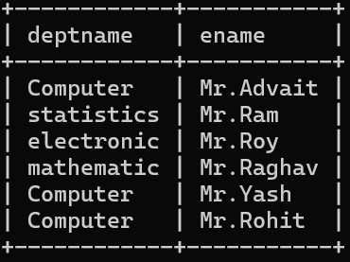

1. **display the total salary of employees of each department. mysql>** select sum(salary),deptname from emp group by deptname;

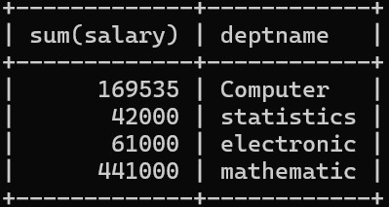

1. **Display average salary of employee of computer department mysql>** select avg(salary),deptname from emp group by deptname;

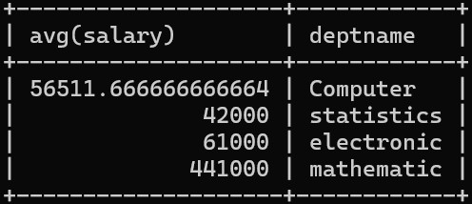

1. **Count the total number of employees of each department mysql>** select count(eno) as Total_Count,deptname from emp group by deptname;

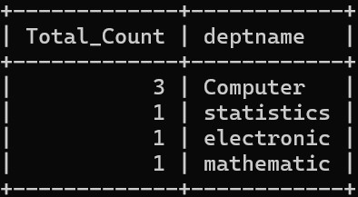

1. **Display top 5 records of employee which are live in mumbai and salary<10000 mysql>** select eno from emp where city='mumbai' and salary<10000 limit 5; Empty set (0.00 sec)
2. **display the employee details having minimum salary mysql>** select * from emp where salary=(select MIN(salary) from emp); **11) Display the name of department whose location is “Pune” and “Mr. Advait” is working in it.**

**mysql>** select deptname as Department_Name from emp where city='pune' and ename='Mr.Advait';

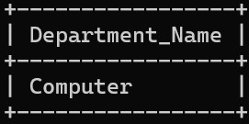

1. **Display the details of each employee whose designation is ‘Manager’.**

**mysql>** select * from emp where designation='Manager';



1. **Display the employee details city wise whose salary is greater than 5000. mysql>** select eno,ename,city from emp where salary>5000 group by eno,ename,city;

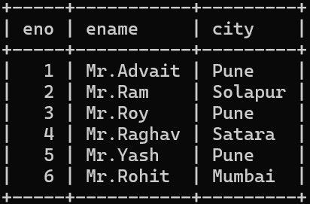

1. **Company has decided to decrease the salary by 15% for all the employees whose salary is between 10000 to 50000.**

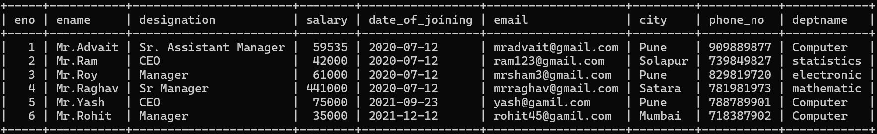

**mysql>** update emp set salary=salary-(salary*0.05) WHERE salary Between 10000 and 50000;

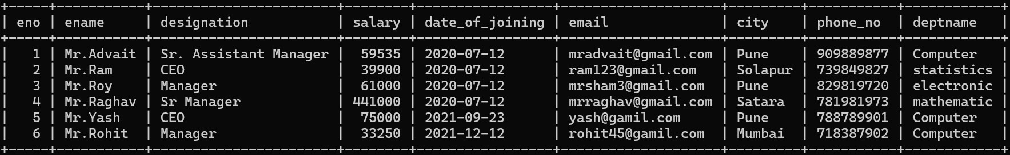

1. **Calculate & display id, name & annual salary of employee (use alise).**

**mysql>** select eno,ename,salary*12 as annual_salary from emp;

